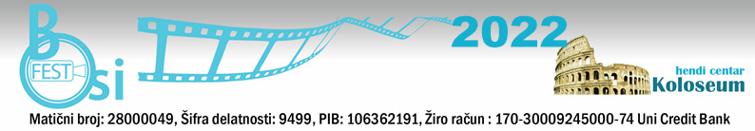
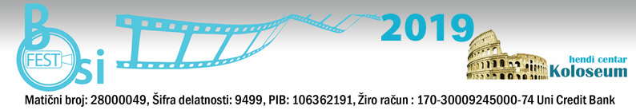

WE HEREBY INVITE YOU TO SUBMIT YOUR WORKS FOR PARTICIPATION
BOSIFEST 2022 – The thirteenth Belgrade International Film Festival for and by People with Disabilities
"BOSIFEST 2022"
From 24th to 26^{1h} October 2022
Venue: Yugoslav Cinematheque, Uzun Mirkova 1, Belgrade, Serbia

HENDI CENTRE KOLOSEUM ANNOUNCES
Submissions for BELGRADE INTERNATIONAL FESTIVAL OF DOCUMENTARY FILM FOR AND BY PEOPLE WITH DISABILITIES – BOSIFEST 2022 are now open.
the topic is work and life of the people with disabilities.
Submissions are open from february 3rd 2022, until April 20th, 2022.
The official selection results will be announced on jul 13th, 2022.
BOSIFEST 2021 will be held from 24th to 26th October 2022.

The festival is competitive; the entire program consists of both competitive and non-competitive parts. Films that are not chosen for the competition part of the program, and meet the requirements of the competition, will be in the non-competitive part of the program.

AWARDS:
-Best Film GRAND PRIX 2022 BOSIFEST
-For best director
- For the best-case scenario

The festival is organized by Hendi Center Koloseum, Panciceva Street 14, Belgrade, Serbia.
The festival was supported by Yugoslav Cinematheque.

The application rules and requirements:
1. Genre: documentary films dealing with the issues concerning people with disabilities
2. Duration: up to 100 minutes
3. The film must be in English or with English/Serbian Subtitles
4. The film must be produced in the last 5 years
5. The film must be sent no later than April 20th, 2022.
6. BOSIFEST accept entries on Filmfreeway,Festhome, or link by email film@bosifest.rs , hc.koloseum@gmail.com
7. BOSIFEST can use parts of the received materials for advertising purposes (up to minutes)

It is necessary to submit the following supporting material:
- Plot synopsis or textual expose lengths between 100 and 200 words
- Dialogue-list (if any)
-Two film captions or photographs of the filming process
- The author’s biography and photo
-Year and place of birth of the film author/authoress, occupation, place of residence and contact information (phone and e-mail)

In addition to the film submissions, submissions for the additional activities and workshops proposals are open. Workshops will be held during the BOSIFEST 2022 at the festival venue.

Questions about the submissions should be sent to: film@bosifest.rs,hc.koloseum@gmail.com
Phone / fax: +381 11 263 78 20 (10-14h)
For more information:http://bosifest.rs

Festival Director
Darko Ivic

