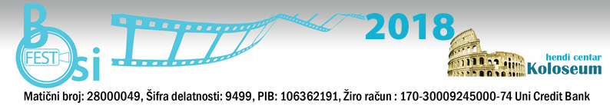

Application form

Film title:

Genre (documentary film):

Length: hours minutes seconds

Production Year:

Original language:
Plot synopsis or textual expose (up to 100 words):

The author’s name:

Contact person:

Contact address:

City:

Zip code:

Country:

Telephone/fax:

E- mail:

Website:

Statement:

BELGRADE INTERNATIONAL FILM FESTIVAL FOR AND BY PEOPLE WITH DISABILITIES

I give my permission for the film
to be shown at BOSIFEST 2018, which takes place from 10thto 12th October 2018 free of charge.

And I allow that the clips from film
may be used for promotional purposes of the BOSIFEST 2018 up to 1 minute length.
Signature: Date, place:

The application rules and requirements:

- Open to all interested applicants
- Genre: documentary films dealing with the issues concerning people with disabilities
- Duration: up to 120 minutes
- The film must be in English or with English/Serbian Subtitles
- The film must be produced in the last 7 years
- The film must be sent no later than April 20th, 2018.
- All videos must be in DVD format
- BOSIFEST can use parts of the received materials for advertising purposes (up to minutes)
- The Selection Commission has to receive at least two copies of the film (DVD format), and the Festival will retain all copies.

It is necessary to submit the following supporting material:
  - Plot synopsis or textual expose lengths between 100 and 200 words
  - Dialogue-list (if any)
  - Two film captions or photographs of the filming process
  - The author’s biography and photo
  - Year and place of birth of the film author/authoress, occupation, place of residence and contact information (phone and e-mail)

In addition to the film submissions, submissions for the additional activities and workshops proposals are open. Workshops will be held during the BOSIFEST 2018 at the festival venue.
BELGRADE INTERNATIONAL FILM FESTIVAL FOR AND BY PEOPLE WITH DISABILITIES

Films and supporting materials should be marked “BOSIFEST 2018 Submissions" and sent to:

Hendi Centar Koloseum,
Pančićeva 14
11000 Belgrade
Serbia

Questions about the submissions should be sent to: film@bosifest.rs
Phone / fax: +381 11 263 78 20 (10-14h)
For more information: http://bosifest.rs

